**Enemy Hit Points**

**Objective:** We’re going to give our Enemies health so they don’t just die after one hit.

**Challenge:**

* Give our enemies health
* Different Enemies should have different Health
* Each time the Player hits an enemy the score should still go up
* Enemy explodes at zero health
* BONUS: Implement hit VFX

**Solution:**

1. Create [SerializeField] for health



1. In **OnParticleCollision** set a condition so that the enemy is not destroyed with one hit

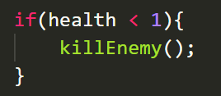

1. Decrease the health in **processHit** method

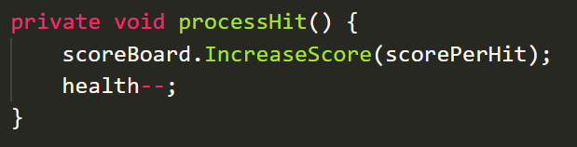

1. Make a copy of one of your Explosion VFX prefabs and name it **Hit VFX**
2. To make it smaller I changed:

|  |  |
| --- | --- |
| Duration | 0.1 |
| Start Speed | 0.52-3 |
| Start Lifetime | 0.1-0.2 |

1. Remember to highlight all of your enemies and add the hitVFX prefab into the Hit VFX field in the inspector



1. Create a [SerializeField] for **hitVFX** under deathVFX

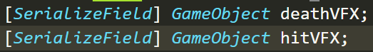

1. Copy the first two lines in killEnemy method (vfx lines) over to processHit and change it to **hitVFX**

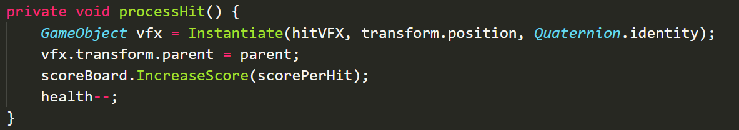

Its okay to name it vfx since these are local variables that only exists inside of the method

**POSSIBLE BUG** IF THE ENEMY IS NOT BEING DESTROYED ITS BECAUSE THE PARENT DOES NOT HAVE A RIGIDBODY ONLY THE CHILDREN ie the parts that make up the ship. SIMPLE FIX ADD RIGID BODY TO PARENT

1. in fact lets just add it to the Enemy.cs script so it automatically does it for us

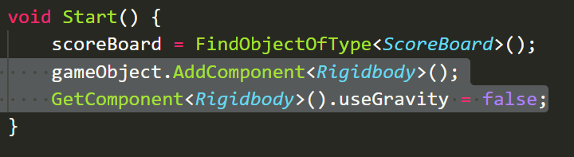

1. Refactor it lets save the component when we create it

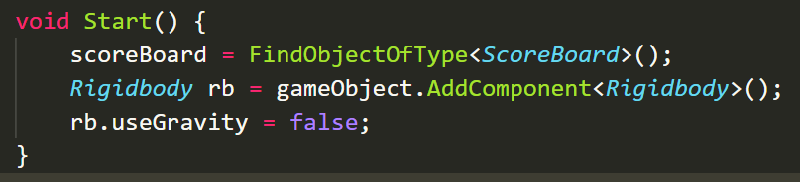

1. Make a method out of it called **AddRigidbody**

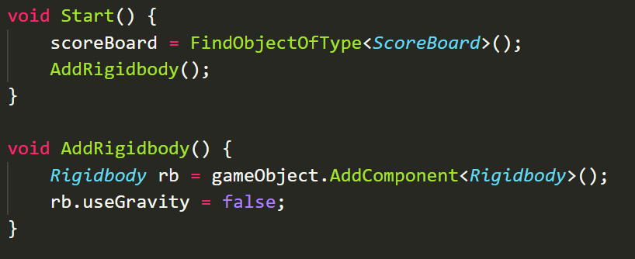

Challenge: Create 5 enemy variants with different sizes, health

Also if youre having a hard time hitting the enemies add a box collider to the prefabs or increase their size